# RoboRugby Strategy Report

**Team Number:** 10

**Team Name:** Bot the Builder

**Authors:** Aaron Collier, Clodagh Dunne, Fergal Lonergan

## Introduction

We understood as a team that the deciding factor in the RoboRugby competition will be a good strategy, and the ability to implement it. Our team have tried to look at this aspect of the competition from every possible outcome to hopefully come up with the best possible strategy to beat opponents and hopefully win the tournament. This report gives a summary of the design process, our idea generation and finally the details of the strategy that we have chosen.

## Brainstorming Ideas

Our brainstorming sessions started small, outlining what our basic aspirations and goals where for the tournament and eventually developed into a well-developed thought process of idea generation and debate. We all agreed that we must do all in our power to win however on some aspects we deliberated slightly until we all came to a general consensus of what the best way to proceed was. We decided to go for something that was going to be effective yet we also had to cater for what was actually possible with our skill set. We then came up with three strategies, looking at each strategy’s pros and cons, and pulled from these to make our final strategy. These where….

## Strategy Ideas

**1)** **All-out Attack**.

In this strategy the robot begins facing the opponent’s goal. The aim is to turn and go straight for the white and yellow balls on our half of the table and the cube in the centre of the table, collect all of them (cube included). After this the robot will turn and drive back to our own scoring area dropping the cube in our own scoring zone and collecting all the balls on our side of the table. The robot will then proceed up the right side of the table as we look at it collecting all the balls in its path and dumping them in the opponent’s scoring zone, we intend to have quite a large collection area. If the robot crashes it would use the beacons to reposition itself. A time limit is set so if there is ten seconds left and the robot isn’t in the scoring position it stops what it is doing and goes to scoring position.

Pros;

* We score plenty of points (8-10) if we don’t get them in conversion zone (16-20) if we do.
* We will clear our own scoring area out in the process of collecting more points.
* The opponents will lose points from the cube.
* There is the option of dropping something in our scoring zone preventing the opponent from scoring.

Cons;

* There is a high probability of crashing into the other robot if they head for the centre of the table first as well.
* The cube could prove tricky to deal with, hardware and software wise.
* If the opposing robot builds a wall then there is no way of scoring and robot could become disorientated.

**2) Defend, defend and defend.**

In this strategy our robot starts facing back towards its own scoring zone. Once the match starts the robot then drives to its scoring zone and collects the balls from our scoring zone. The robot drops a blocker into our own conversion zone and then proceeds up the right side of the table collecting and counting the balls, then stopping and parking in the opposing team’s conversion zone. If we have collected enough we stay otherwise we hunt. If the robot crashes it would use the beacons to reposition itself. A time limit is set so if there is ten seconds left and the robot isn’t in the scoring position it drops everything and goes to scoring position.

Pros;

* The projected score if we get all our balls into the conversion zone is 22 points. This is more points than what would be left on the table.
* There are no tricky bits of programming involved.
* The strategy should be able to be carried out quite quickly if the robot is quick.
* Simplest strategy to program, apart from ball counter.

Cons;

* Again there is a high likelihood the robot will meet the other robot if it comes South potentially ruining the strategy.
* A large collection zone for the balls would be required potentially slowing the robot down.
* If the opposing robot builds a wall then there is no way of scoring and the robot may just crash into barrier continuously.

**3) Fire at will.**

Start by collecting the four balls around the cube but not the cube itself, then clear out the balls around our scoring zone. The robot then proceeds up the right hand side of the table collecting balls and parking in the opponent’s conversion zone. If the robot runs out of time and it hasn’t/can’t reach the scoring zone then it uses the beacons to point itself in the right direction and “fires” the balls towards the scoring zone, using the servo as a throwing arm.

Pros;

* If a wall is used then we should still hopefully be able to score points.
* If a wall isn’t used then the amount of points we score will be quite large (34 if we get them in the conversion zone).
* No hassle with the cube.

Cons;

* No way of blocking our own conversion zone to stop the opponent scoring.
* Again there’s a high likelihood we’ll collide with the other robot if he goes for the centre of the table first as well.
* So many balls will slow the robot down.
* “Firing” the balls properly will be tricky to get right.

**Conclusion**:

All strategies have their positive and negative aspects with none standing out as clear favourites. Having several programs pre-programmed into the robot would be the ideal situation which we could set before each match when we see the opposing team’s robot. We now know we need a failsafe but also that we cannot choose just one of these programs instead we must pull the most positive aspects from them all to create one final “super” strategy…

***Board showing strategies each colour donates a different route. As coloured above.***

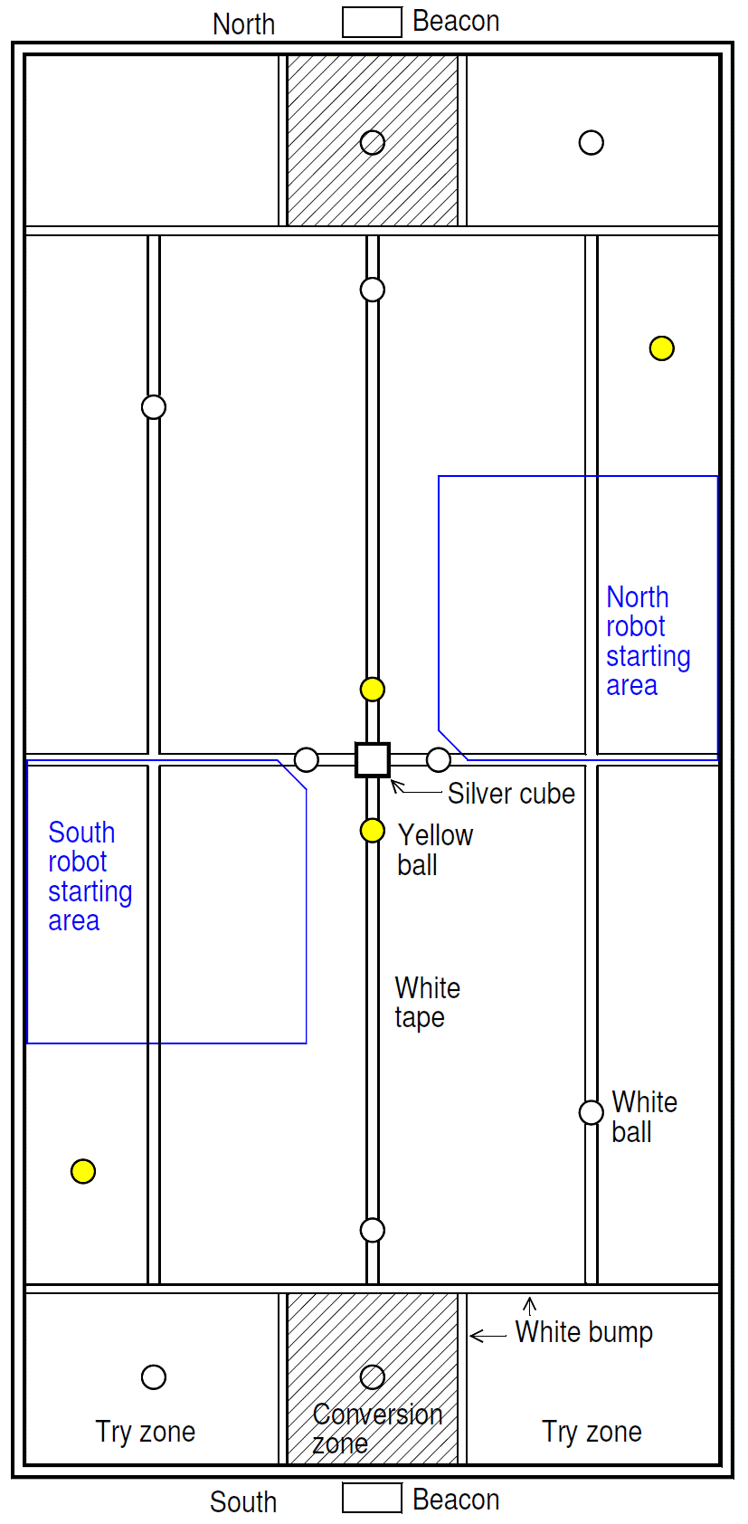

## “Bot the builder”, our final strategy

We decided finally on this strategy which incorporates the best aspects of the previous three strategies with a few more precise details:

-Begin facing our defensive beacon.

-We plan to firstly go back to our own scoring zone and clear out the balls on our side of the table, avoiding the balls around the cube and the cube itself. We have chosen to ignore the cube and surrounding balls as we hope to have a fool-proof primary movement that works the same every single time and we feel that by engaging with variables such as the other robot early on (As they are likely to go for the cube, etc. early on) we could ruin this primary objective.

-We plan to collect the initial five balls on our side of the table in a harvester-like contraption and store them beneath the under carriage of our robot. The under carriage will hold up to eight balls, with a counter to tell the robot when it is full.

-Once the five initial balls are collected we plan to look around the table for three more balls, initially down the side of the table, hoping they have been left untouched in the opening sequences.

-The robot will find the grey zone and stay there once it either: Has collected eight balls, or the timer has gone off for him to find the scoring zone.

-At ten seconds to go (Or however long our actual robot takes to traverse the length of the table plus a few extra seconds) we intend for the robot to search for the beacon for the scoring zone and head towards it, this is part of our failsafe strategy.

-Should the robot be impeded on his way to scoring he will initially try to reverse and move around the obstacle by turning and then finding the beacon again. If that fails and the timer is less than four seconds we plan to use a device on the back of the robot, using the servo, to lift our collected balls up and tip them over the obstacle, like a dumper. We think this is a good idea because, as you have remarked in lectures, the use of a wall or barricade over the scoring zone has become quite popular, so this would be a good way to counteract that.

***Ranking***

-We would implement some changes to our code for use in the ranking round however:

1) We would aim to collect all balls around the cube.

2) We would increase the holding capacity of the robot so that it could accommodate one more ball, so that it could collect all balls on our side of the table and in the centre in one swoop before going to the opponent’s side.

3) We would modify the counter accordingly.

4) We would not utilize the device to tip the balls over.

We feel that getting a good score in the ranking round will be crucial to doing well in the competition, as it will allow us to avoid the "Better" robots until later rounds.

5) We will try to collect all the balls in the ranking round in two sweeps of the board.



We feel like we have considered all other strategies appropriately and that our strategy will work well against all types of robots. It will however, be crucial that our robot is relatively quick as our strategy would be extremely weak if another robot was much faster than ours meaning that it could collect the balls on our side of the table before us.